**EXPERIMENT - 3**

**Important Function in Excel**

* VLOOKUP FUNCTION
* XLOOKUP FUNCTION
* MATCH AND INDEX FUNCTION

**VLOOKUP FUNCTION :-**

VLOOKUP is like a phone book. It helps you find things (like a phone number) based on a known value (like a person's name).

* **Usage :** Use VLOOKUP when you know what you're looking for and want to find related information in a table.
* **Example:** In a list of students with their grades, you can use VLOOKUP to find a student's grade based on their name.

EXAMPLE :-

Here 0 indicate accurate mathup value and 1 indicate approx. matchup.

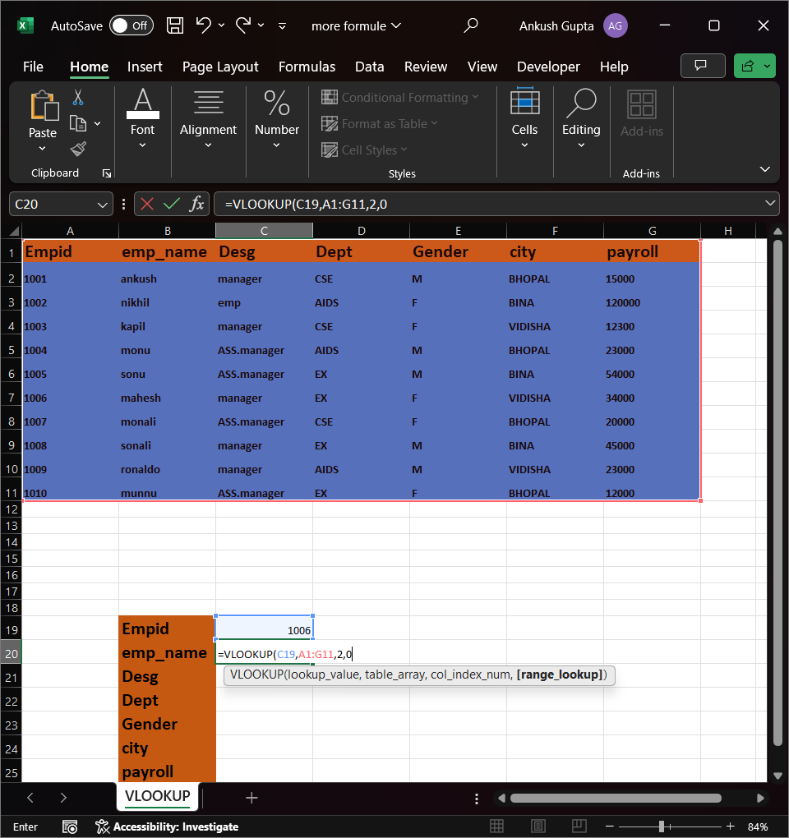

ERROR VALUE GENRATE :-

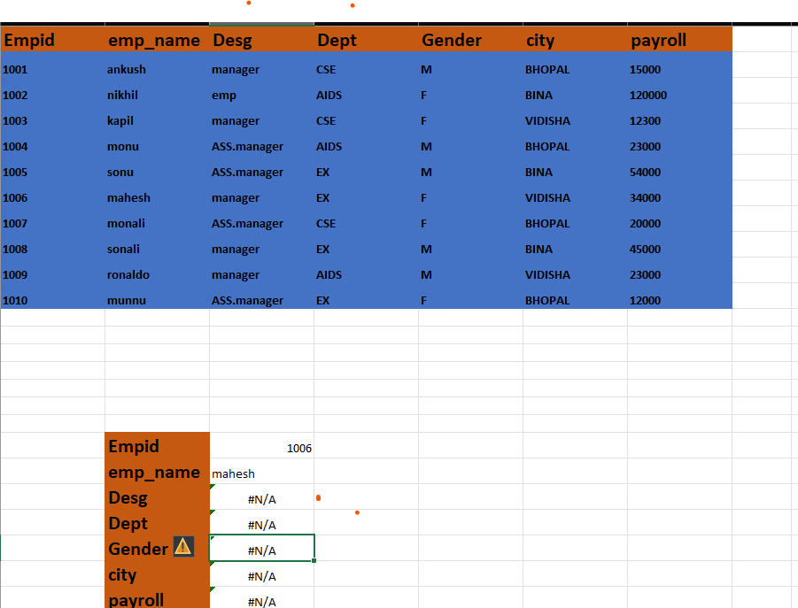

This is a second method or approach two resolve error :-

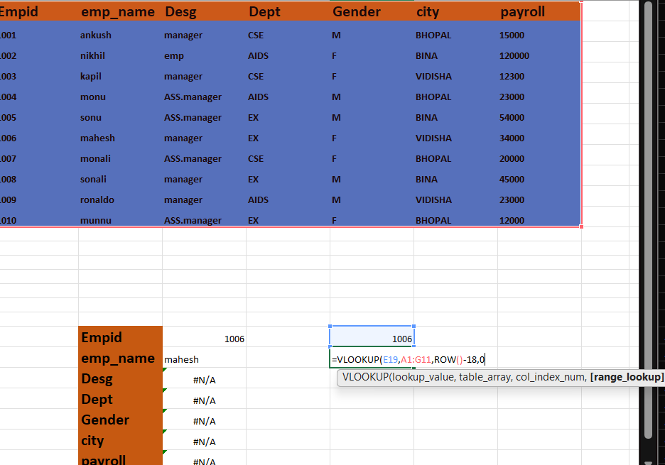

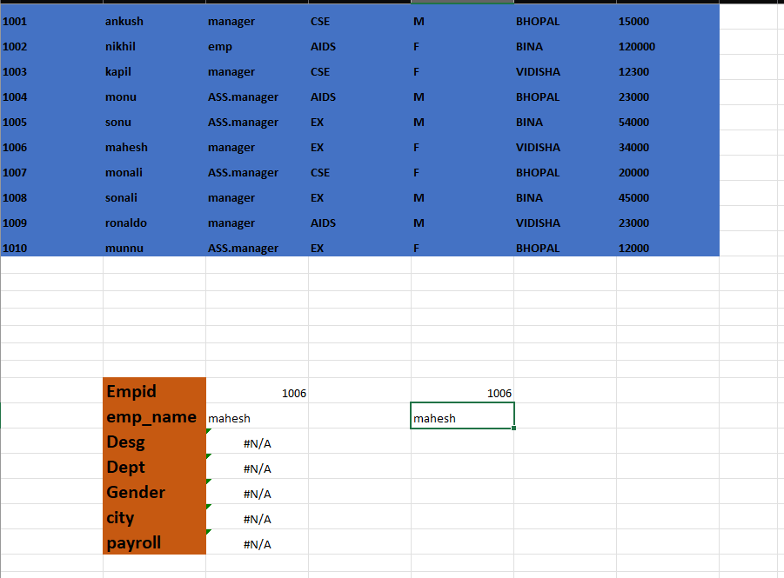

AGAIN GENRATE VALUE ERROR :-

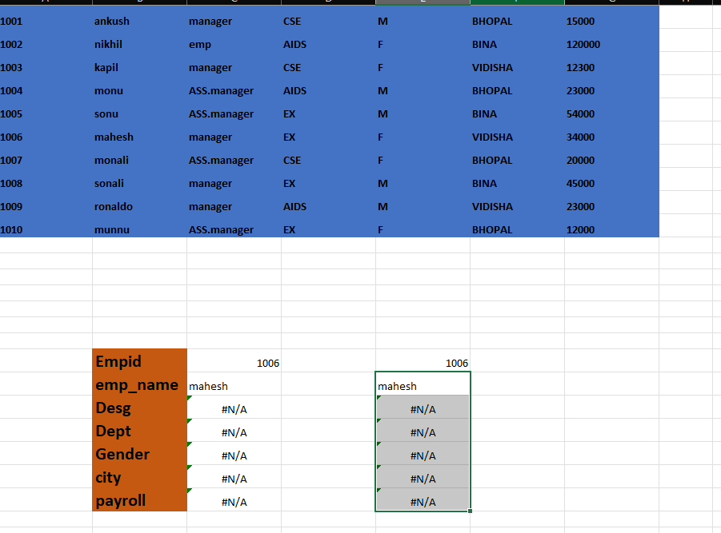

Error generate because of it :-

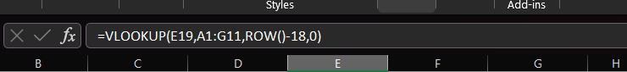

Resolve thorought it



Then output is :-

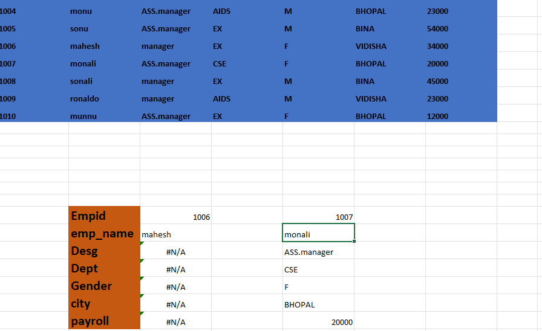

Take argument as a 1 for approx matchup.

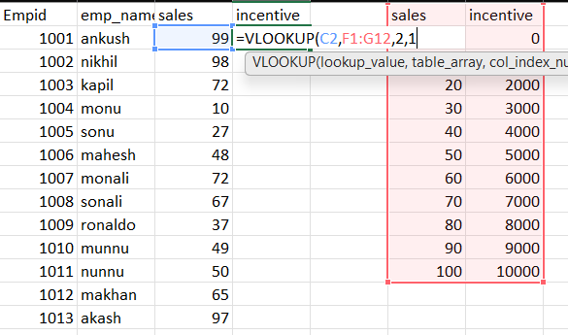

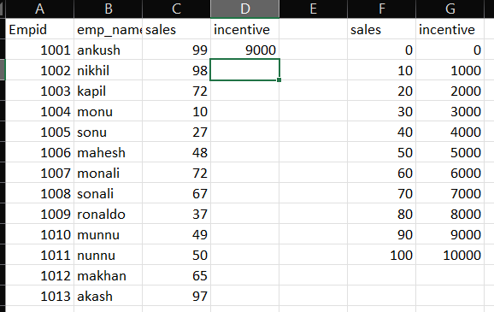

Show value error :-

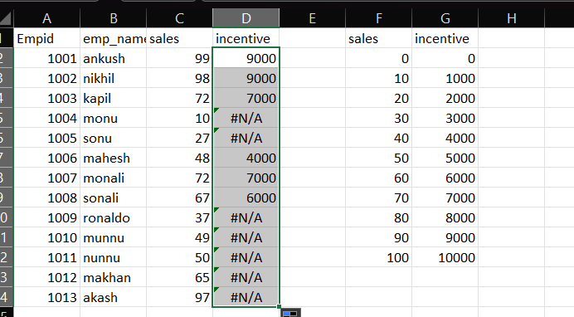

Show value error because of it :-



Resolve this error by it :-

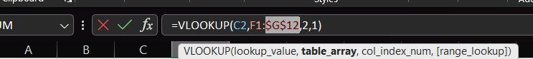

Then output is :-

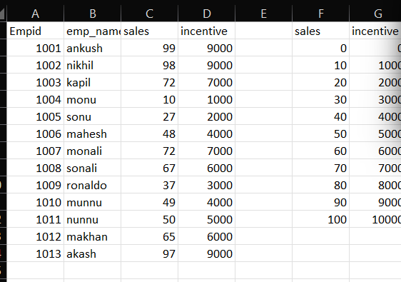

The final data is :-

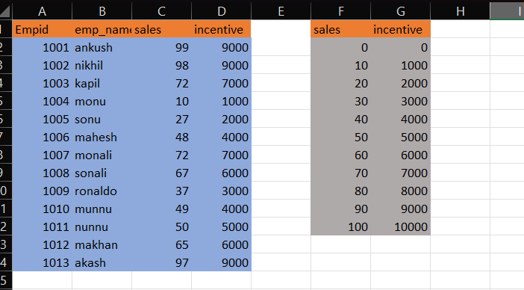

**MATCH AND INDEX FUNTION :-**

MATCH and INDEX (often used together):

**MATCH Definition:** MATCH helps you find the position of something in a list.

**INDEX Definition:** INDEX helps you get the value from a specific position in a list.

**Usage:** Use MATCH to find where something is, and then use INDEX to get the value from that location.

Example: If you have a list of cities and their populations, you can use MATCH to find the position of a city's name and then use INDEX to get its population.

EXAMPLE :-

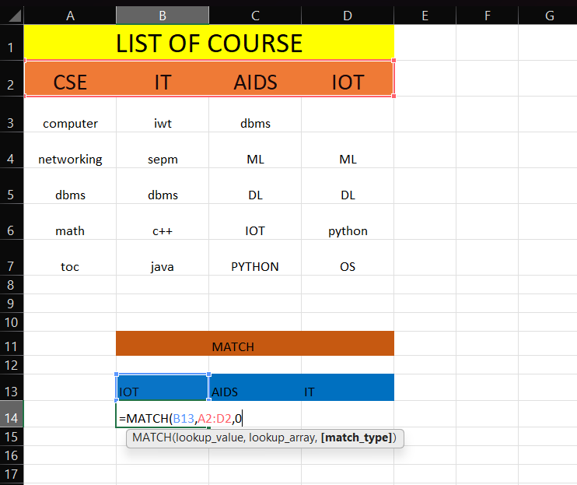

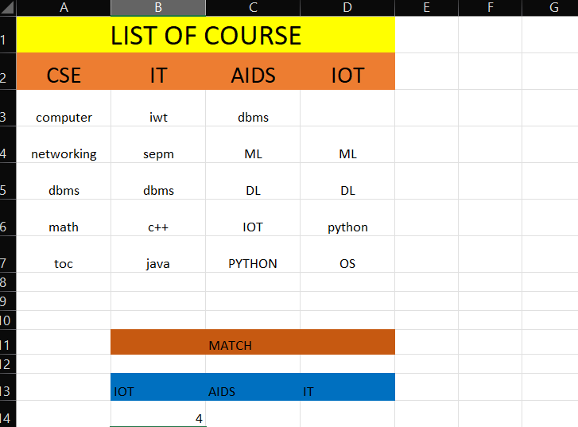

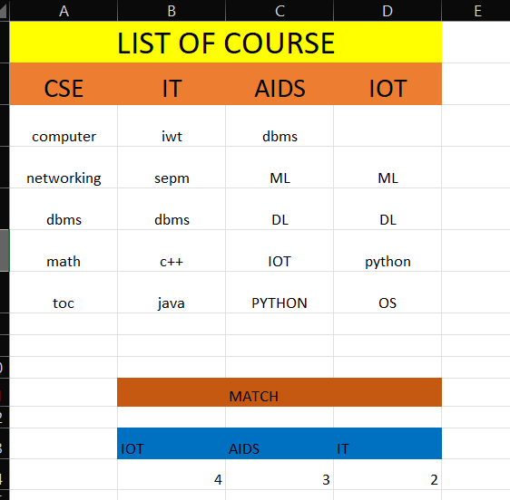

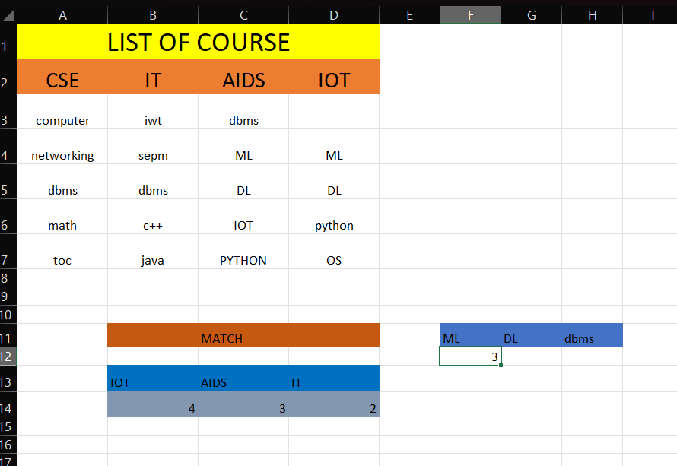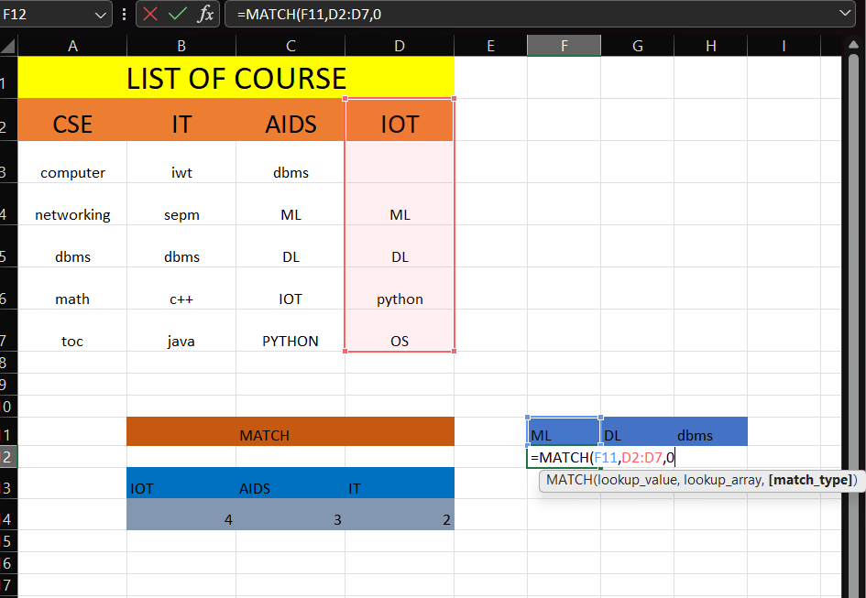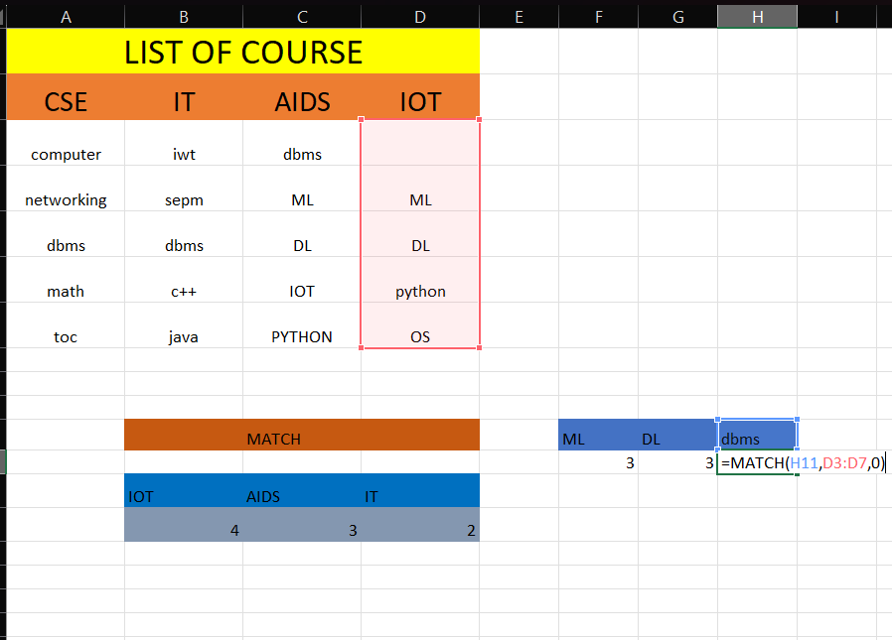

Value not exit in table than show value error :-

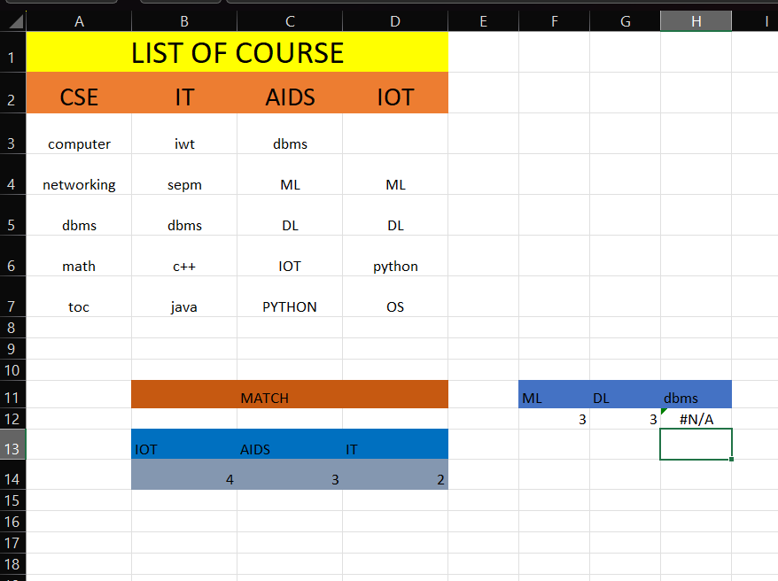

Create List :-

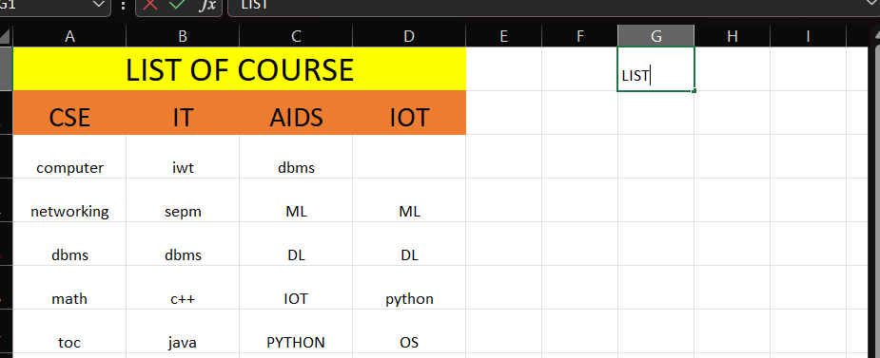

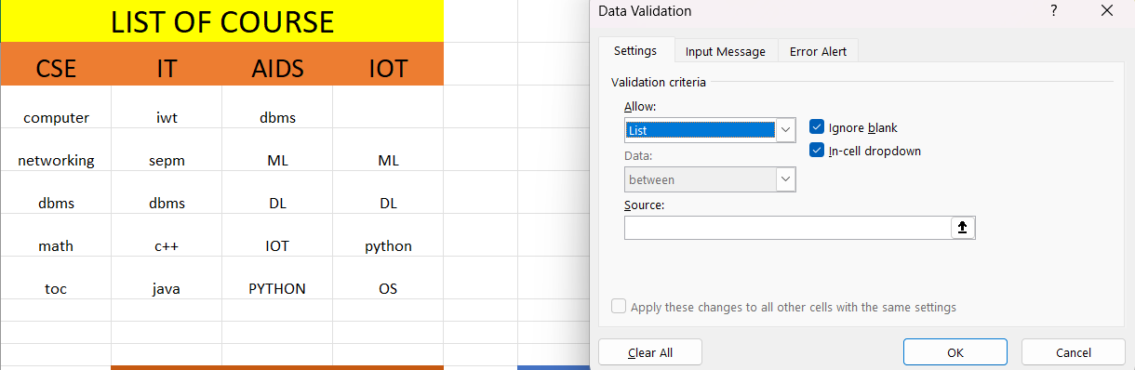

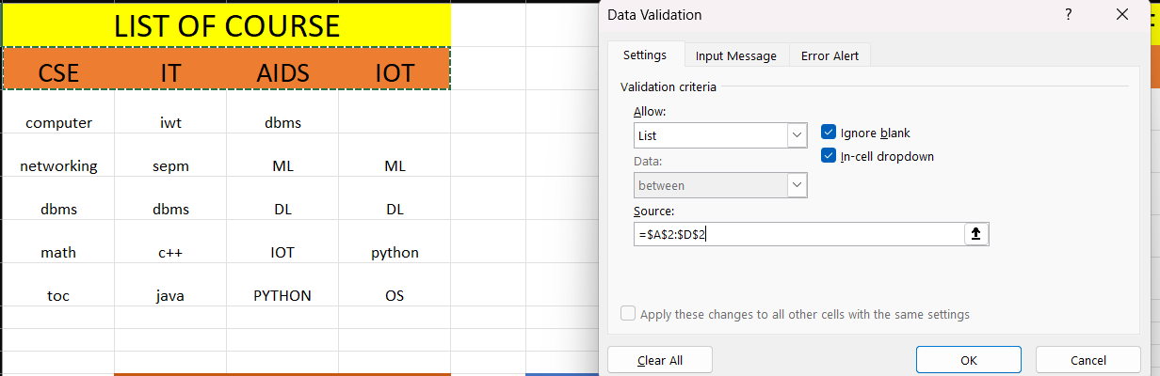

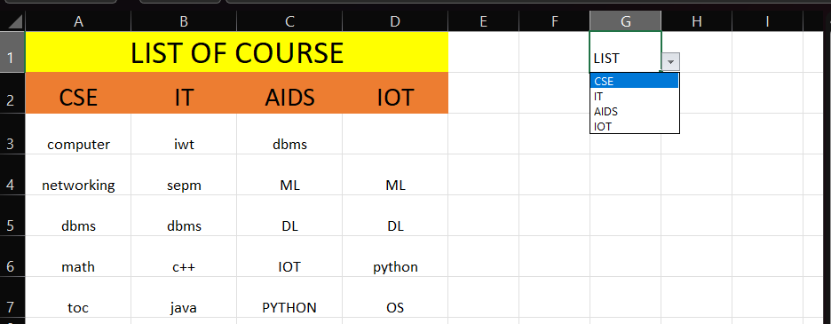

Index function reture value :-

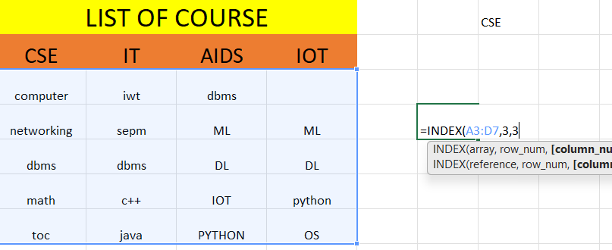

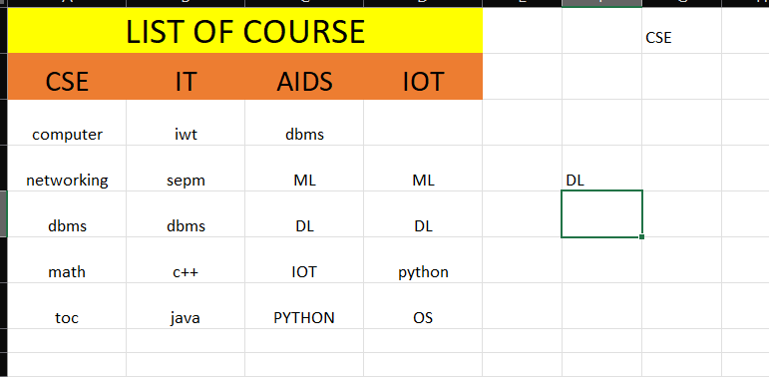

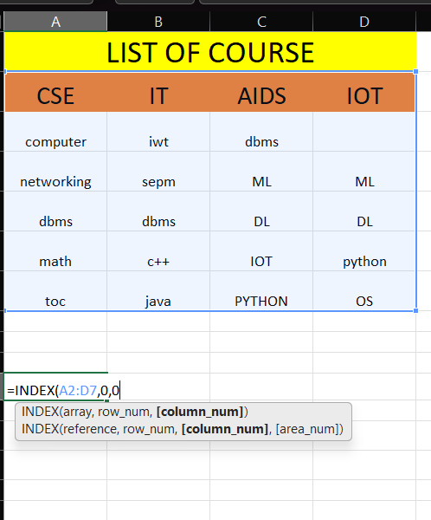

Final pictures

